**MODULE: 2**

**SE – HTML and CSS**

1. Define the terms: Website, Webpage, Web browser, Web server,

HTML,CSS

Website:

A website is a collection of related web pages, multimedia content, and other digital assets that are identified by a common domain name and published on at least one web server. Websites are accessible over the internet or a private local area network (LAN) through a web browser.

Webpage:

A webpage is a single document, typically written in HTML (HyperText Markup Language), that is accessible through a web browser. It can contain text, images, multimedia elements, hyperlinks, and other types of content. Webpages are the building blocks of websites.

Web Browser:

A web browser is a software application used to access information on the World Wide Web. Popular web browsers include Chrome, Firefox, Safari, and Microsoft Edge. Users can enter website addresses (URLs) into the browser to view webpages, interact with web-based applications, and consume various types of online content.

Web Server:

A web server is a computer system or software application that stores and delivers web content to clients over the internet or an intranet. When a user requests a webpage, the web server processes the request and sends the requested files (usually HTML, CSS, and multimedia elements) to the user's web browser, which then displays the webpage.

HTML (HyperText Markup Language):

HTML is the standard markup language used to create webpages. It consists of a series of elements (tags) that define the structure and content of a webpage. HTML elements can represent headings, paragraphs, links, images, forms, and other types of content. Web browsers use HTML to render webpages and display them to users.

CSS (Cascading Style Sheets):

CSS is a stylesheet language used to control the visual presentation of webpages. It allows web developers to define styles, such as layout, colors, fonts, and spacing, for HTML elements. By separating the content (HTML) from its presentation (CSS), web developers can create visually appealing and responsive web designs that adapt to different devices and screen sizes.

2.Create a webpage to show “This is my first HTML page”

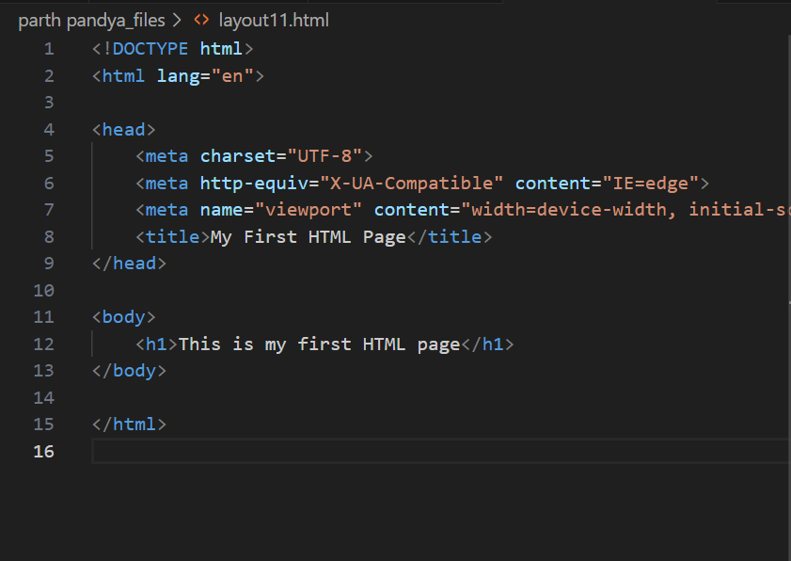

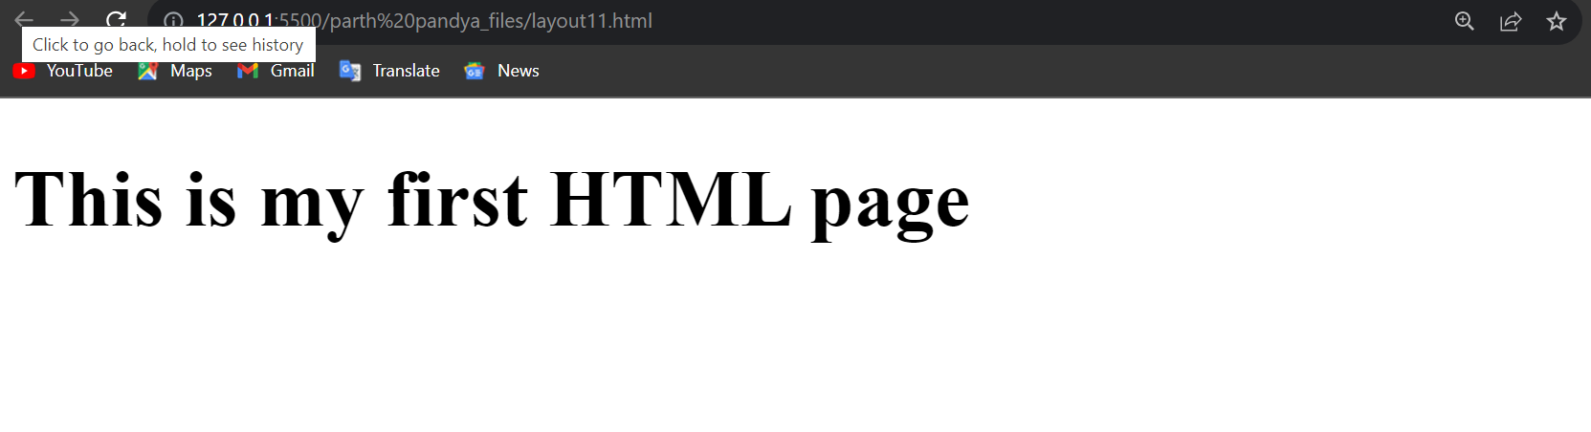

1. Display top 10 IT companies list in html webpage

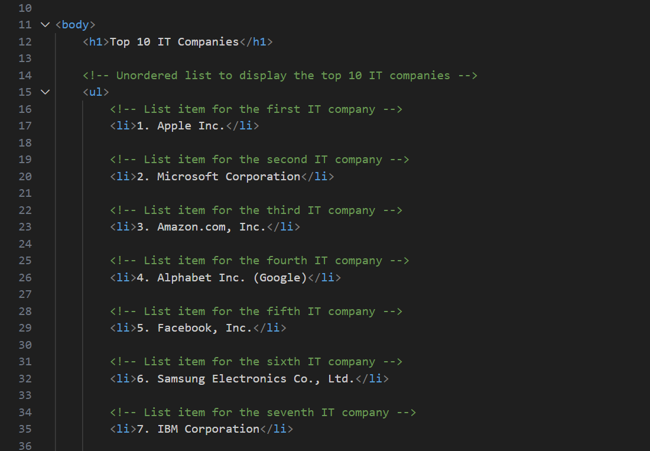

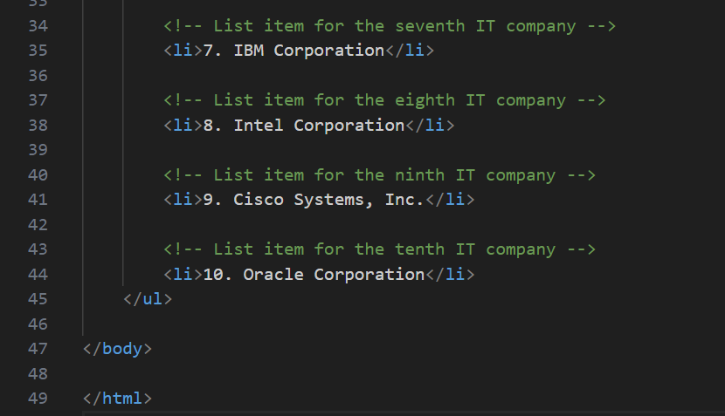

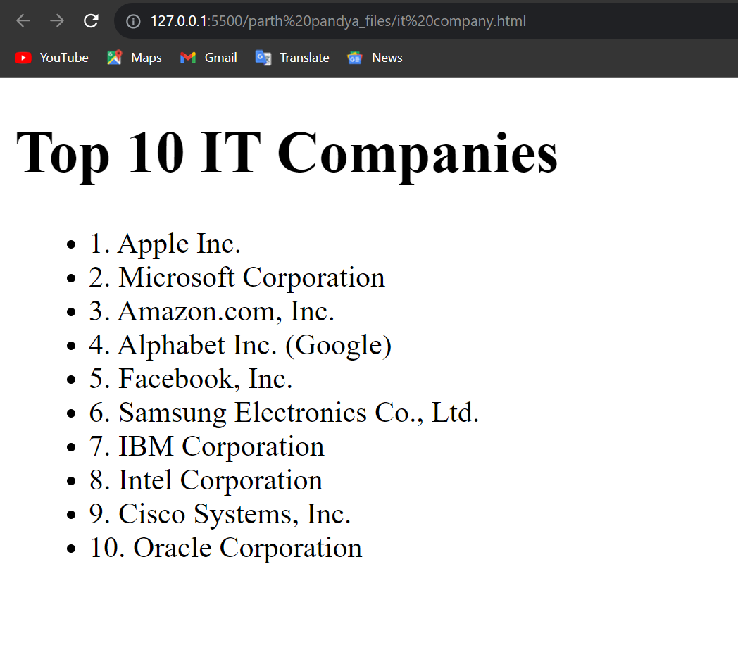

1. Create a dropdown list

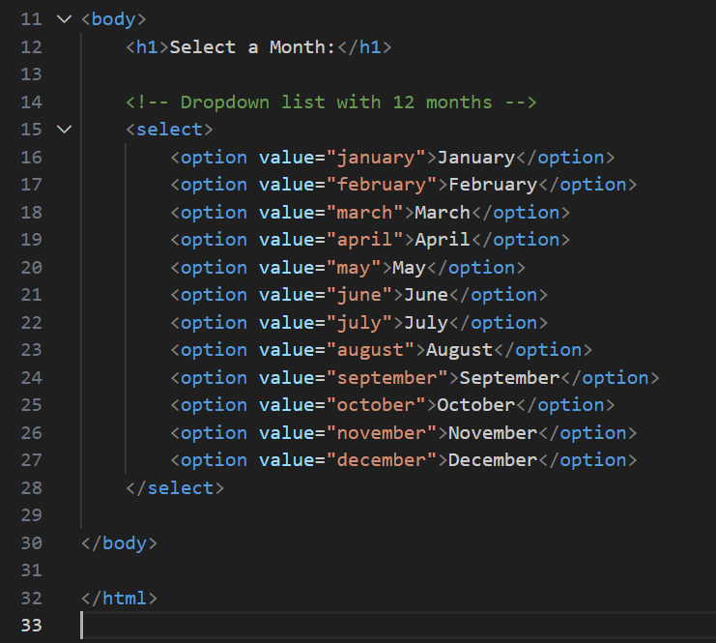

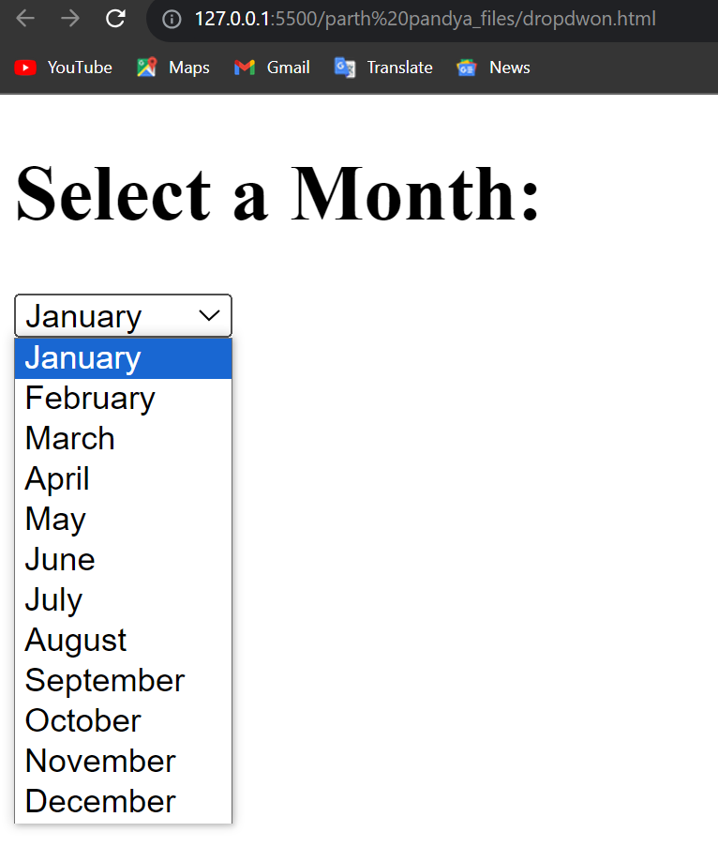

1. Create a Table Of college Management system using row span & colspan.

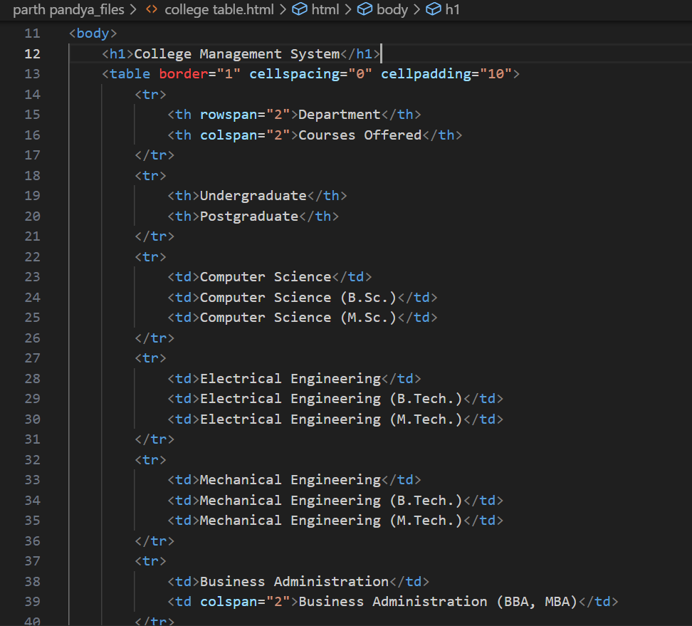

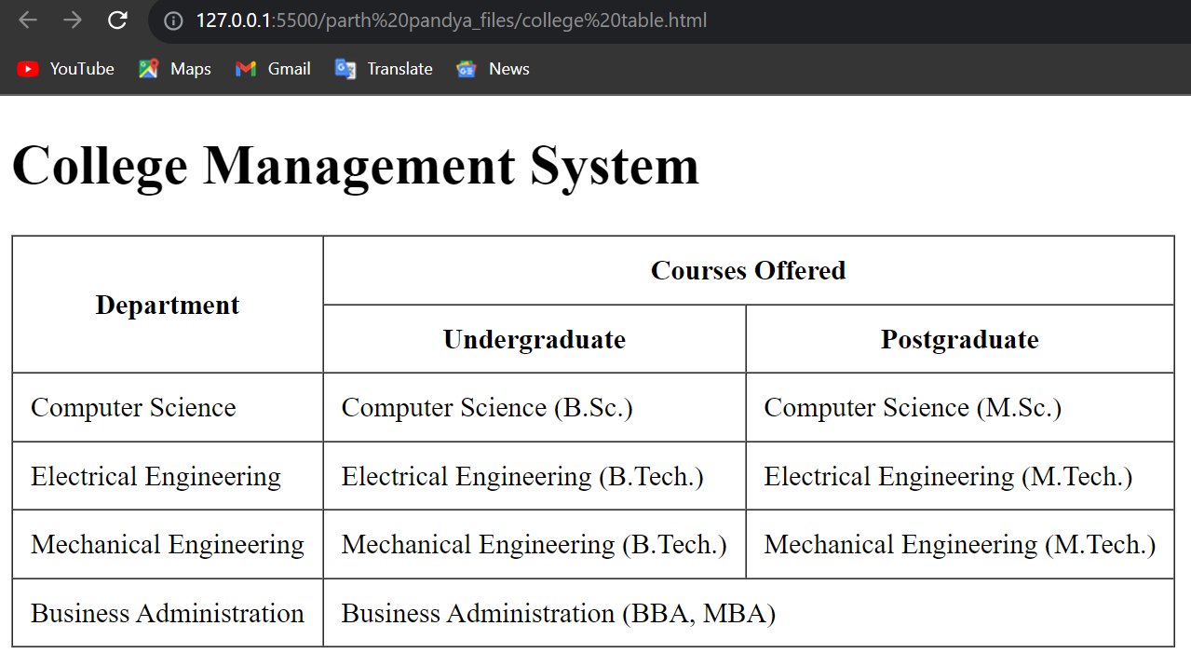

1. Create below table using HTML table tags

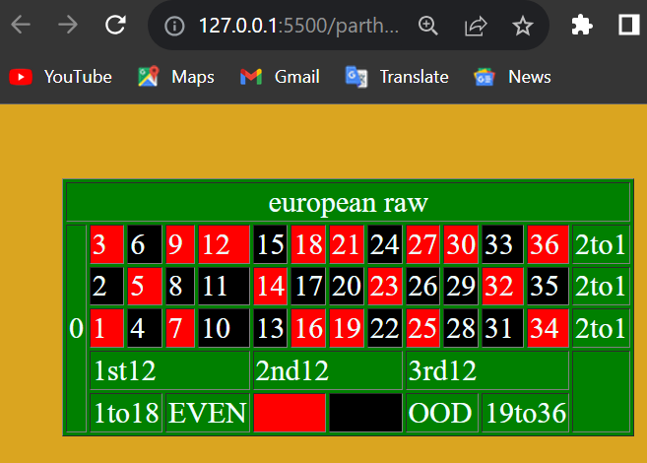

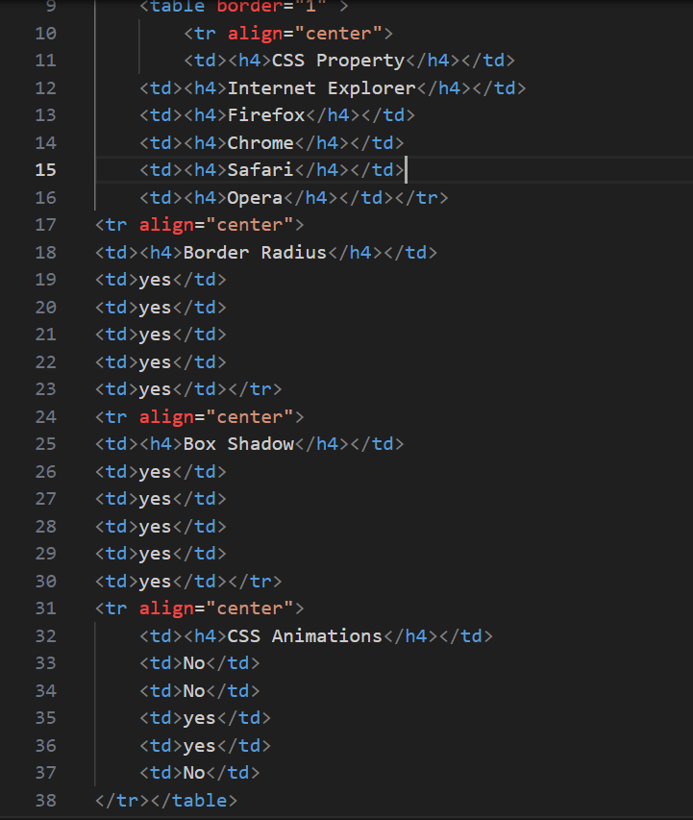

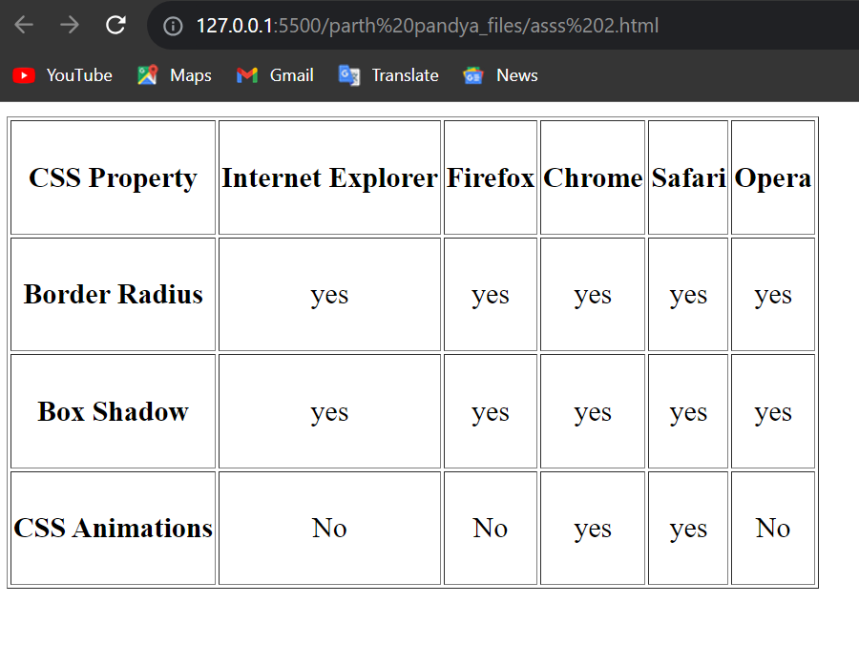

7.Create Registration form using HTML, CSS

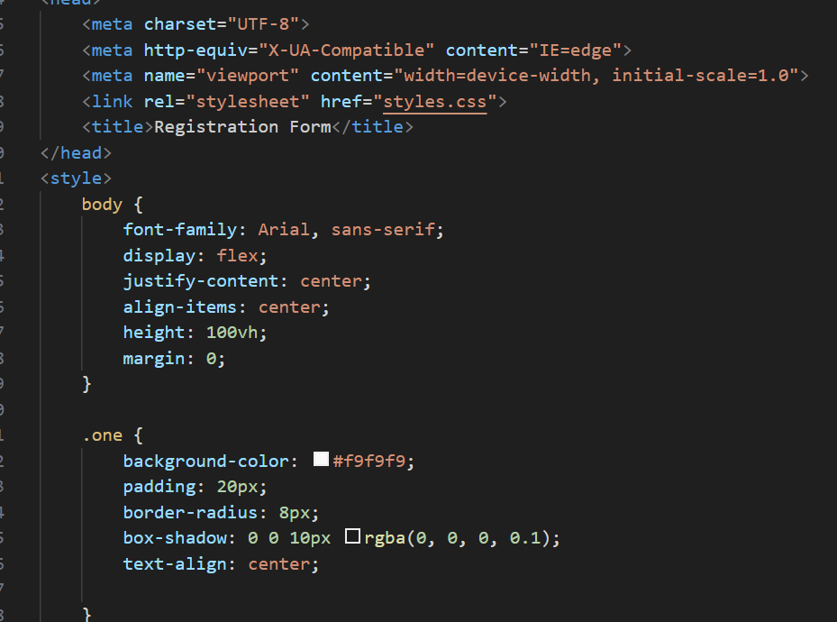

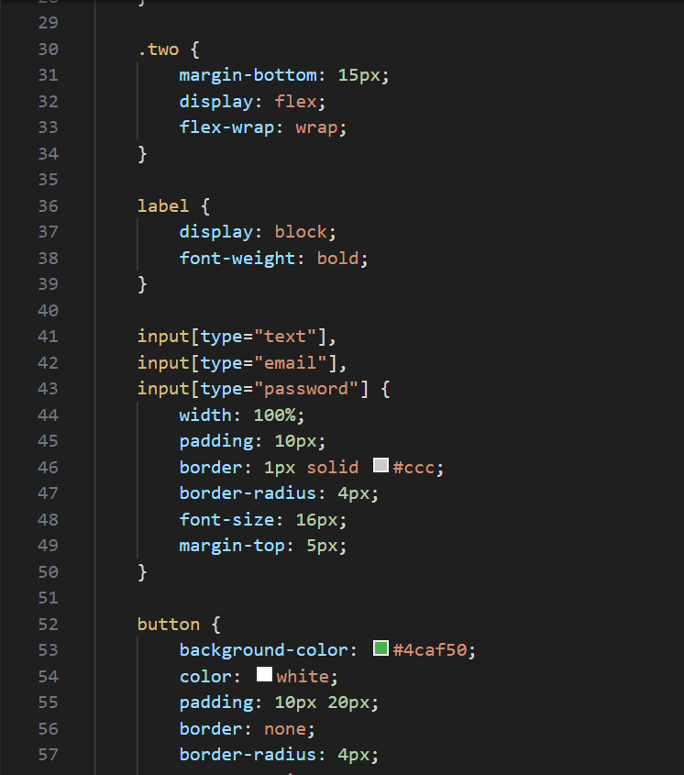

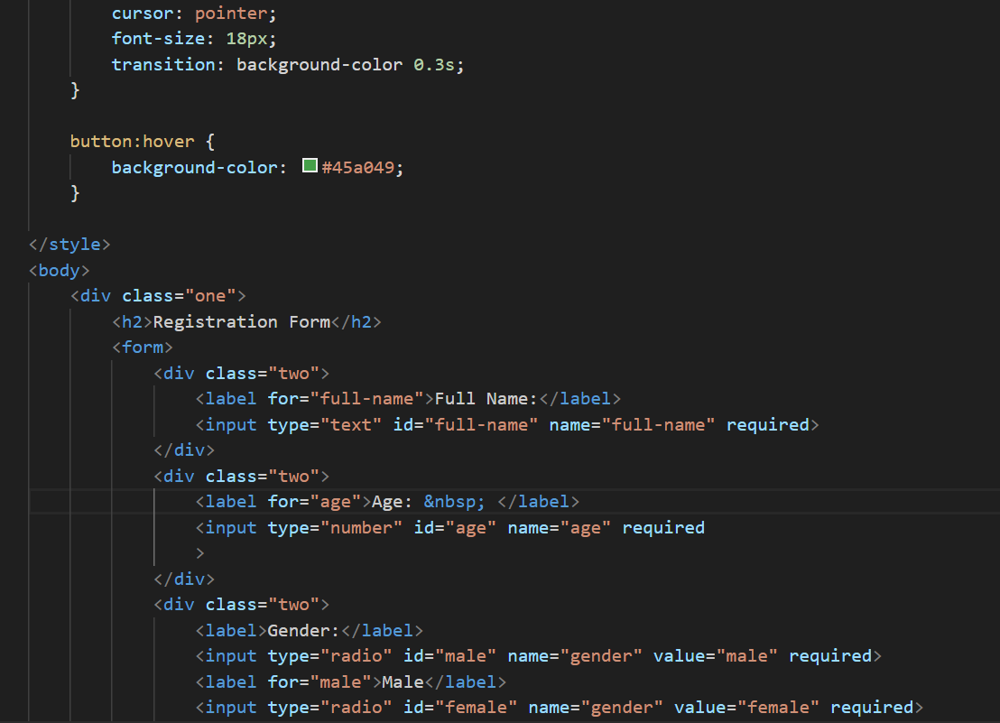

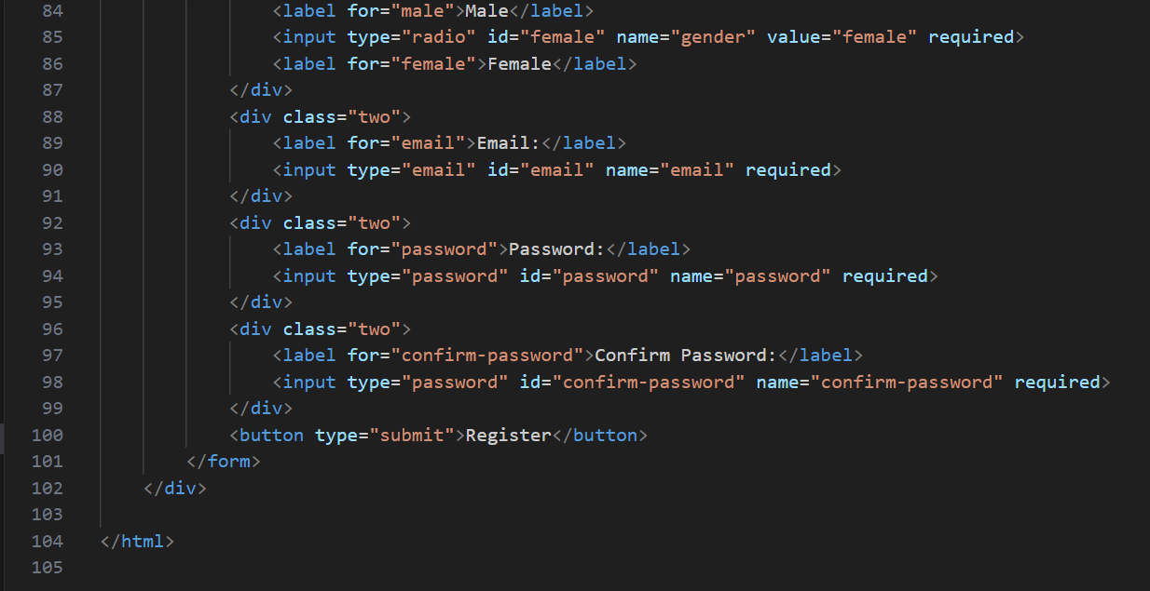

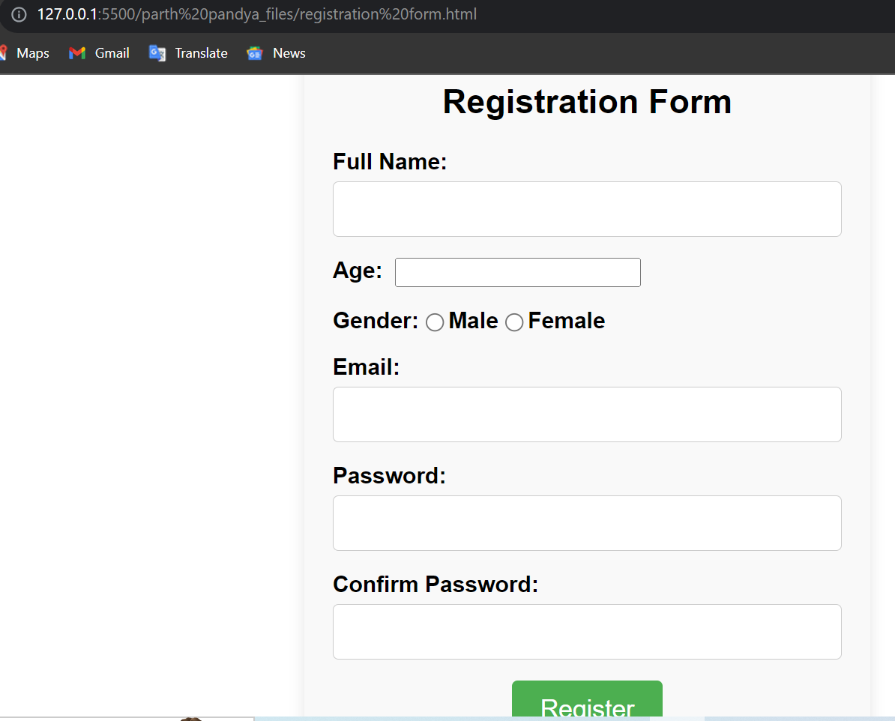

1. In how many ways can a CSS be integrated as a web page?

1. Inline CSS:

Inline CSS is applied directly to an HTML element using the style attribute.

2. Internal CSS:

Internal CSS is placed within the <style> tag in the <head> section of the HTML document.

3. External CSS:

External CSS is defined in a separate .css file and linked to the HTML document using the <link> tag.

9.Create simple three pages using External CSS, Internal CSS, and Inline

CSS.

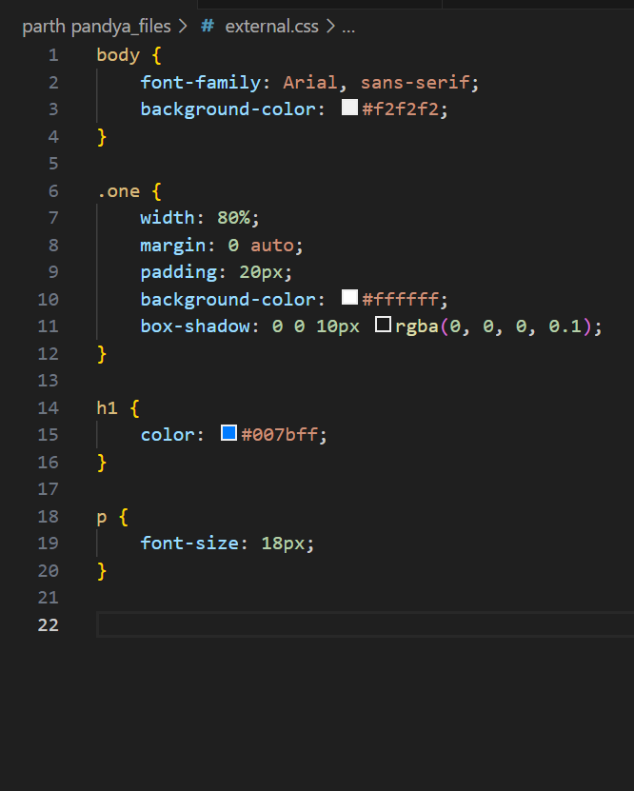

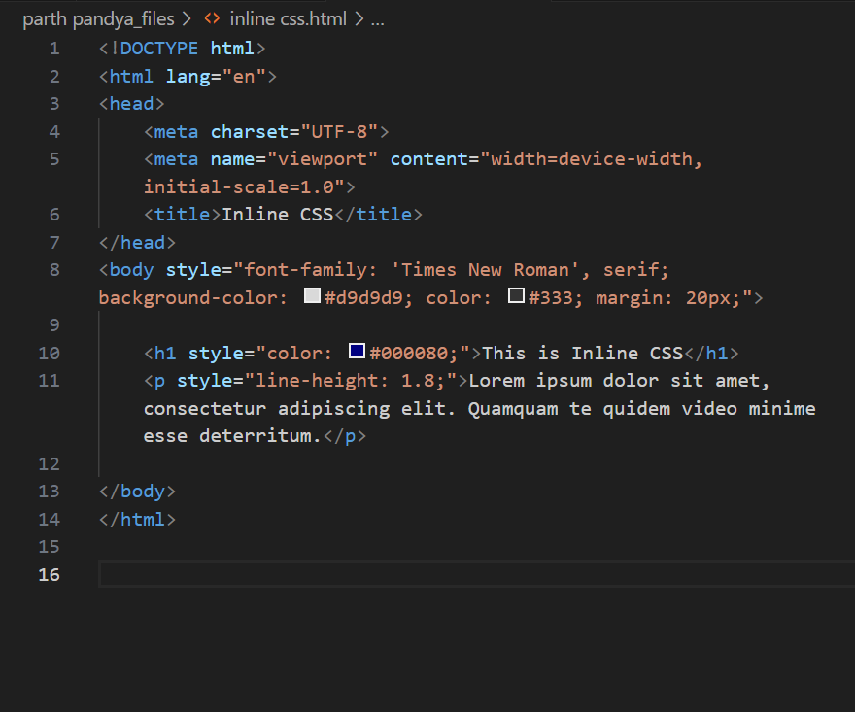

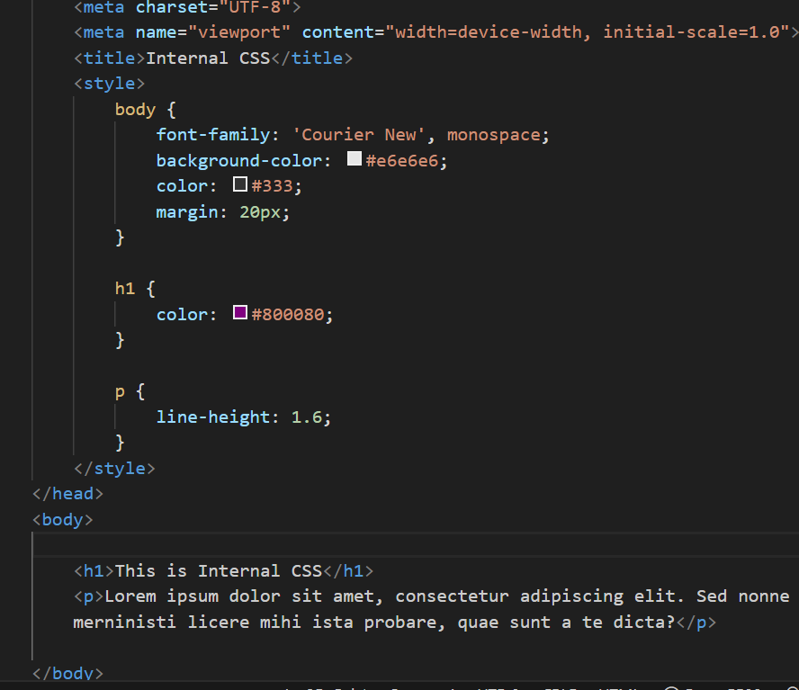

10 . .Create below page using HTML CSS

